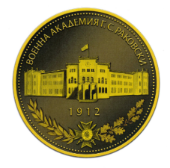

RAKOVSKI NATIONAL DEFENCE COLLEGE
82 Evlogi and Hristo Georgievi Blvd., 1504 Sofia, Bulgaria
www.rndc.bg
Registration Form
International Summer Semester 2024
Please attach your head-and-shoulder photo.
Country of Origin:
Name of the Institute:

Course: | Security and Defence
From:  (dd/mm/yy) | 05/03/2024 | To:  (dd/mm/yy)

Male | Female | Rank | Surname | First name

Date of birth | Place of birth | Branch of Service | Major Academic Field | Academic Year

Passport number | Phone number | e-mail address
ID number | Present address

Arrival at Sofia Airport (yes/no) | Arrival at Sofia railway station  (yes/no) | Arrival date (dd/mm/yy)  05.03.2023 | Time of arrival  TBD
Departure from Sofia Airport(yes/no) | Departure from Sofia railway station(yes/no) | Departure date (dd/mm/yy) | Time of departure

Special dietary or food requirements

Emergency contact/ Liaison staff:
Male | Female | Rank | Surname |  | First name
POC’s phone number |  |  |  | POC’s e-mail address

